**This is my masters project for third semester. Here I tried to build an interactive dynamic mapping system with Django web framework and its different libraries.**

**Python folium mapping library for projecting a mapping system with its geojson files and pandas to manipulate the covid 19 datas to import those datas in the map.**

**Also used restful api http get request to fetch real time covid 19 data from an always updated system.**

**Here below the official project report for this project which I submitted to my faculty which elaborately describes the project and its features.**

**COVID-19 IMPACT MAP**

**(BANGLADESH)**

A Project

Presented to the

Institute of Information Technology

University of Dhaka, Bangladesh

In Partial Fulfillment

Of the Requirements for the Degree

Master in Information Technology (MIT)



By

FUAD AHMED

ID : 201108

MIT-22nd BATCH (2019-2020)

# 

# ABSTRACT

The outbreak of COVID-19 novel coronavirus has highjacked the entire planet. With the world coming to a standstill, thousands lost their lives and economies went under free fall.

Along with other countries Bangladesh has also suffered a lot due to this deadly pandemic. During the early stages of the pandemic last year the whole country was shut down to stop the spread of the virus. Communities and neighborhoods were always fearful and anxious about the current state of there area in terms of the spread of the virus and its deadly affect.

During this period everyone is always eager to know about the spread of the virus throughout the neighborhood and the country. An informative and easy mapping system based on the virus spread have been ideal to deal with this situation perfectly.

# PURPOSE

So, the purpose of the project is to build an effective, updated and interactive map showing the spread of the virus throughout our city, district and country.

A covid-19 impact map that can describe the current situation of the pandemic throughout the borders of the country; featuring the infection rate of a certain area and details about the area like day to day positive test cases, death rates etc can be the key features of the mapping.

Although the information part of the map should be based on real updated information provided by the health ministry but there can be more done with those information. Like judging by the infection rate of a certain area, the map should be able to warn the neighboring areas of that certain area and mark them as potential risky area for increase of infection in the future.

**LIST OF CONTENTS**

**SIGNATURE PAGE** 2

ACKNOWLEDGEMENTS 3

ABSTRACT 4

PURPOSE 5

LIST OF CONTENTS 6

**METHODOLOGY** 7

**IMPLEMENTATION** 8

AUTO UPDATED DATA SYSTEM 8

PLOTTING THE MAP 9

DETAILED VIEW OF PARTICULAR DISTRICT 10

RISK ASSESMENT FOR NEIGHBOR DISTRICT 16

LIMITATIONS 20

**CONCLUSION** 21

**METHODOLOGY**

Django (Python) web framework

Reason:

1. Different Python libraries like folium; is used for visualizing geospatial data. Folium is a Python library used for plotting interactive maps and pandas for importing data from different file formats in order manipulate data to use in effective way possible.
2. Python dynamic web template attributes like filters/tags/variables help build dynamic web pages for different parts of the country and make the structure of the pages static and easy to understand.
3. Restful api features help to extract real time data from sources which creates an always updated information system of the current covid-19 data of Bangladesh.

**IMPLEMENTATION**

Auto updated data system:

Data gathered from covid-19 dashboard ([বাংলাদেশ (Bangladesh) জাতীয় ড্যাশবোর্ড | গণপ্রজাতন্ত্রী বাংলাদেশ সরকার | People's Republic of Bangladesh (corona.gov.bd)](https://dashboard.corona.gov.bd/webportal)) which is a source from health ministry updated regularly .

A RESTful API uses different commands to obtain resources. The action should be indicated by the HTTP request method that we’re making. The most common methods include GET, POST, PUT, and DELETE. The get method is used to retrieve data from resources.

Here in our system we used (get) http request method to gain raw data and then saved the data in a csv file in the system for the further use of the system.

Clearing up the gathered data so that only useful information(according to the system) are left without the unnecessary information along with it.

Example:

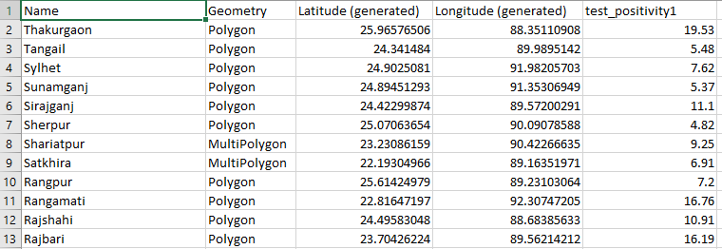

Reading the geo-data for the requested area(district / divisions) to build map:

To build a choropleth map, you need 2 data inputs:

1. a set of geographic regions and their boundary coordinates
2. a numeric value for each region, used for the color

Using geojson data representing the regions and boundary of Bangladesh and a reliable data indexed by similar id of the geojson file we plotted the map in the system.

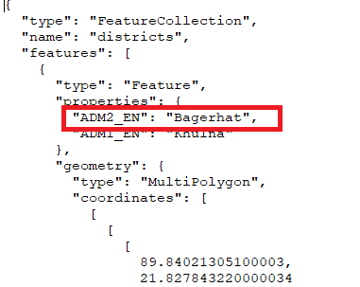

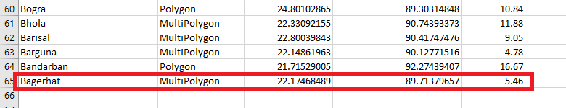

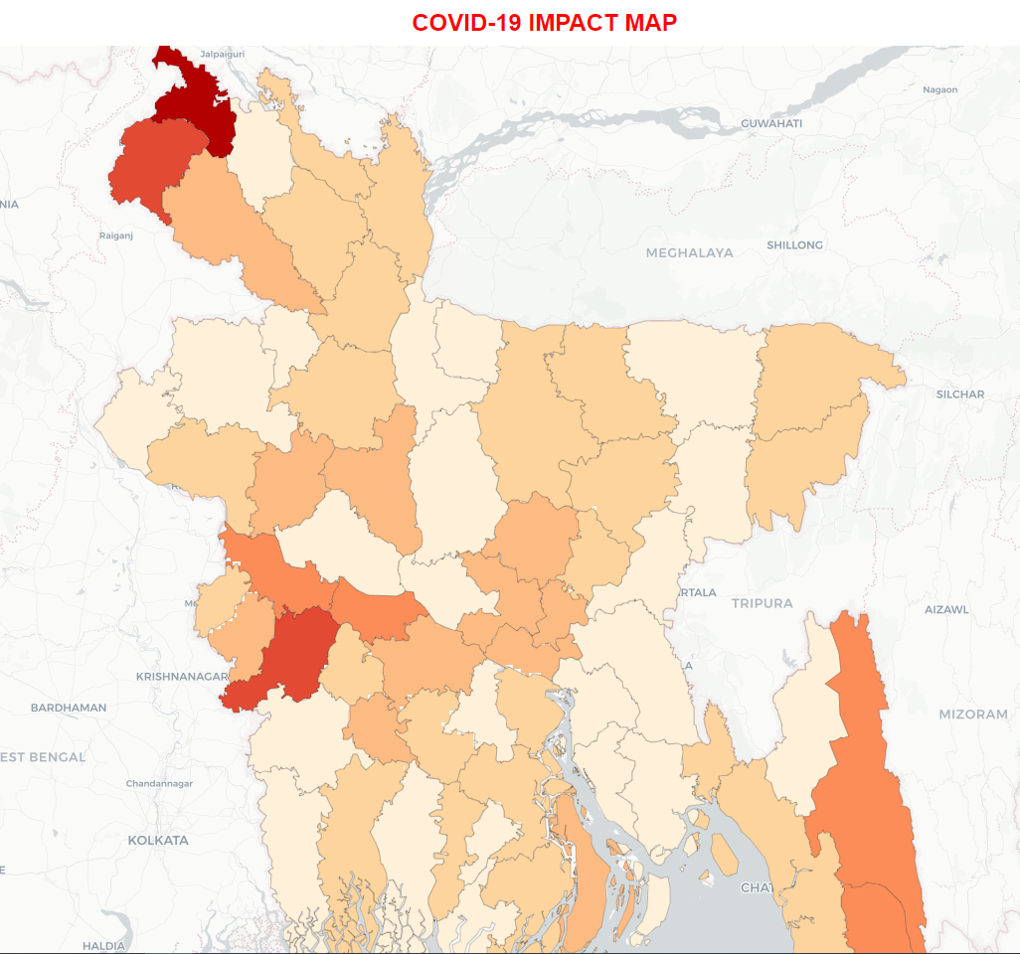



Plot all cases(infection rate) on the Bangladesh map (districts)

Then on that map (folium) markers to represent each districts details like district name and infection rate. Different colored folium markers represent different infection rate of the districts

1.Blue marker (3%-5%)

2.Orange marker(5%-10%)

3.Red marker (11%-28%)

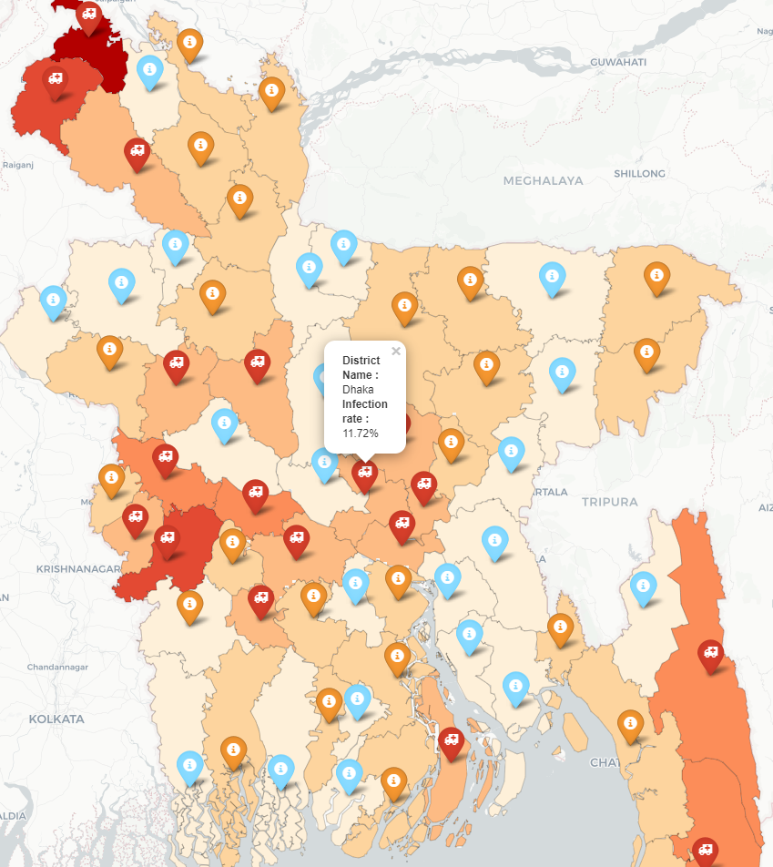

Detailed view for each districts separately:

While displaying the whole situation of the country each marker represents each districts. In those marker the name of the district contains a link which would take it to a new tab where detailed information of the district would be shown with the help of a graph(folium vega-graph).This goes for every districts as the system is build using dynamic template features of Django web framework.

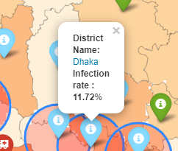

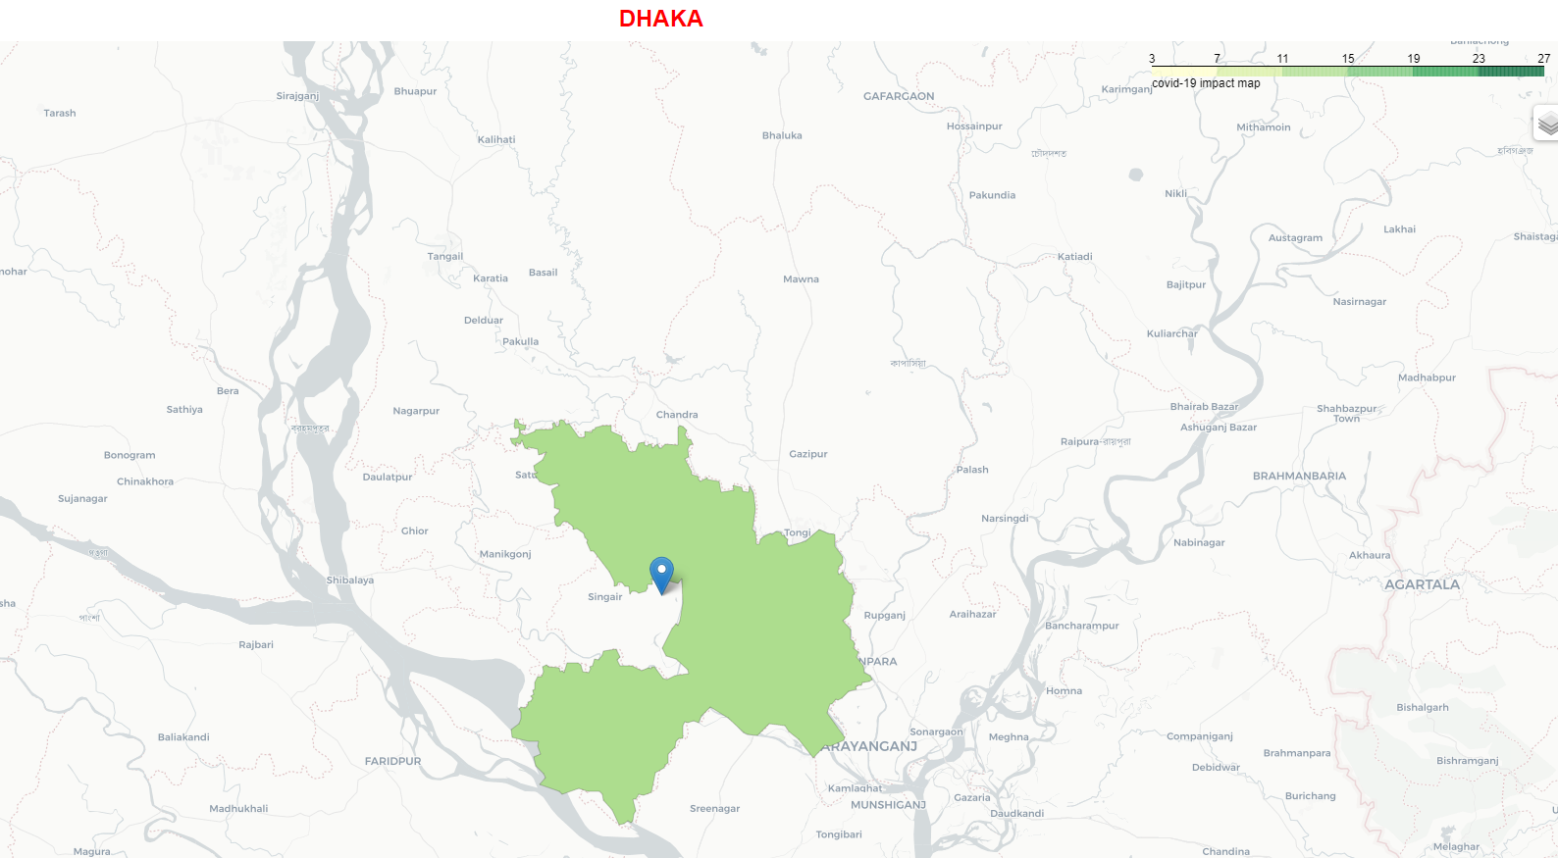

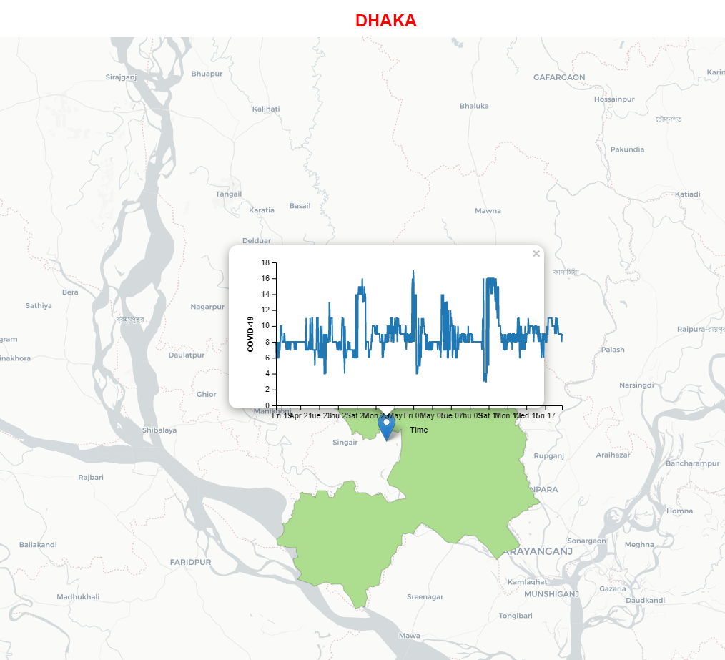

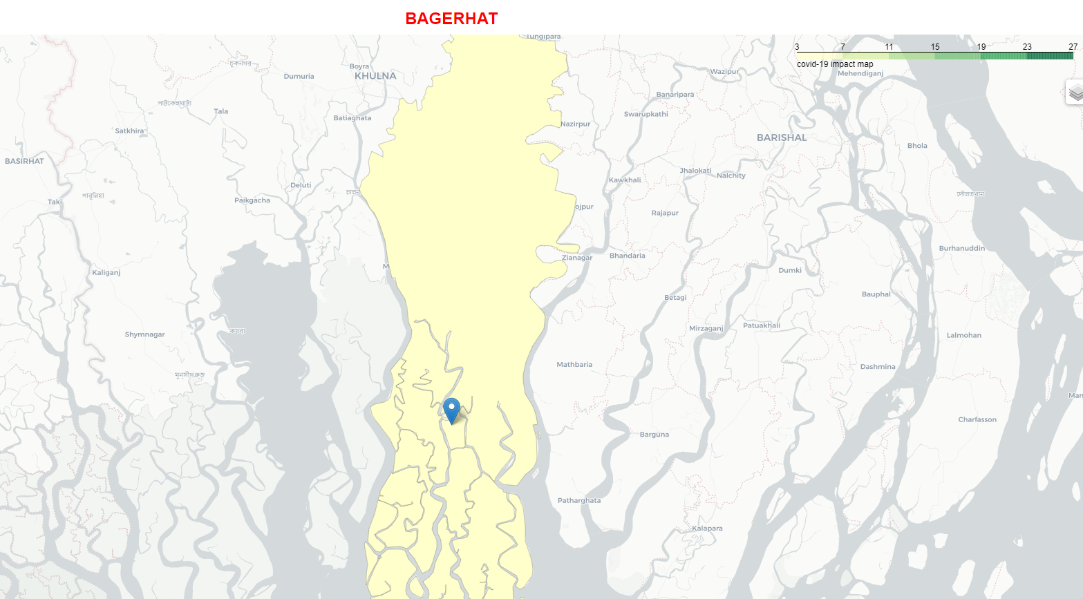

Risk assessment for neighbor district:

One of the key features of the project is to process the highly infection districts information in such a way so that other districts which are in risk of spread of the virus can be notified.

Here for each red markered districts we also show potential risky districts using (folium) circles on top of the marker of that particular district’s neighbor district. While viewing the first look of the map the user can easily detect which districts are severely infected and which districts are in potentiality of high risk of future infection.

Process:

step-1:

* Whenever we have found a red marker popup representing a state with high infection rate we have divided that area in four regions as taking the latitude and longitude of the district as the center of an (x,y) graph and calculation its distance to other districts in those four regions to find out the neighbor districts of that particular district.

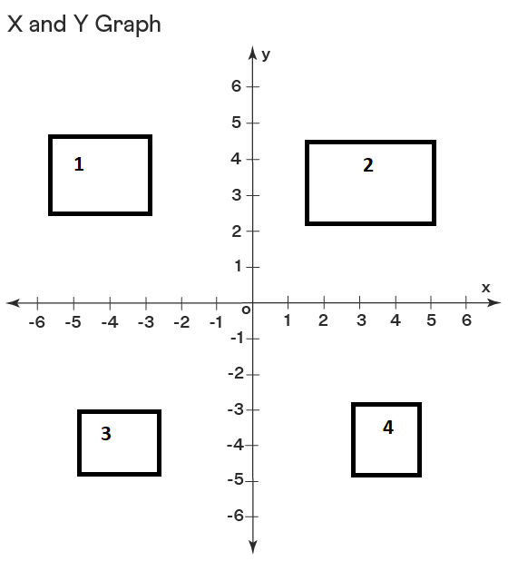

Step:2

* Then in those four regions we found the nearest neighbor district of the highly infected region and the declared them as potential risky state with the consideration of their own infection rate.
* As if a neighbor district is already affected or not affected at all that district wont be considered as potential risky state.
* 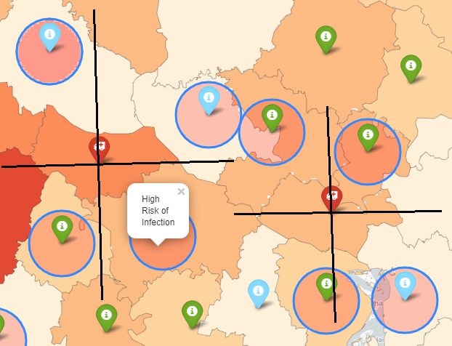

Full view of the map:

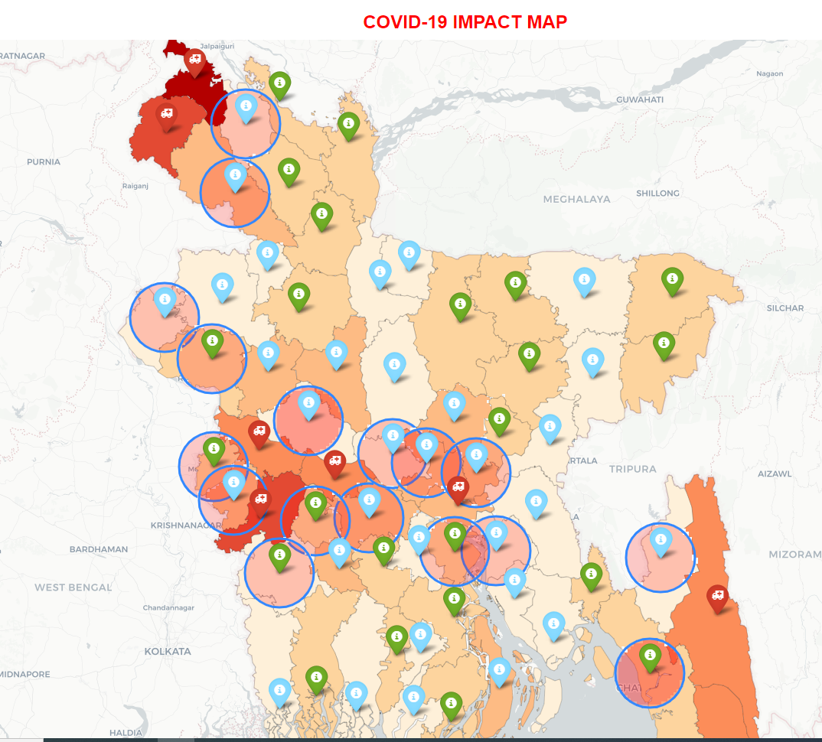

**Limitations**

Due to lack of geojson file for every single sectors individually like upazila thana etc the choropleth map does not support the detailed view of smaller areas just like the district wise view.

Also for lack of detailed updated covid-19 data now-a-days due to the vaccination process and the progress of controlling the virus, the representations have some lacking in terms of in depth view of the map.

There are a lot of valuable information that can be shown in the process like vaccination number, vaccine centers etc. In future those features will surely add the detailed informative view of map and complete the purpose of the project fully.

**CONCLUSION**

Here, in this project the aim was to represent the covid-19 situation in Bangladesh with use of advanced mapping and different statistics to help people understand the day-to-day scenario of pandemic in our country in order to stay updated of our own surroundings and also keep in touch of the other areas of our country.

Although it is a mapping system that represents the covid-19 situation of certain areas of our country, but the structure of the system is build with dynamic template features so that a detailed mapping system with geojson file of a certain area and supporting document which can be anything like agricultural stats (which area in our country grow which kind crops or which areas consume which kind of vegetables), business stats etc can be displayed dynamically for the better understanding of that topic throughout the country.